**STANDARD NOTES**

**LESSON NOTES FOR APTITUDE FOR TOP CLASS TERM I**

Taking care of myself for proper growth ad development.

My name is ___________

I am ____ years old. I am a__________ (girl, boy)

My father’s name is _____________

My mother’s name is ____________

I live/stay at ____________

My school is ______________

Activity

1. What is your name?

My name is _________________

1. How old are you:

I am ________ years old.

I am a _______________(girl/boy)

Let the pupils talk about themselves.

1. What’s your father’s name?

__________________________

1. What’s your mother’s name?

_______________________

1. Where do you live/stay?

_______________________

1. What’s the name of your school?

___________________________

Drawing and describing his/her name.

Naming my body parts

1. reciting/singing a rhyme about body parts.
2. Naming and identifying body parts e.g ears, toes, nose, mouth, fingers, legs, eyes, lips, etc.

Teacher leads pupils to know how many they are.

All about functions of each body part e.g.

eyes - seeing

nose - smelling

legs - walking, etc

* Children should know the main function of body parts. i.e to give shape of person.

The teacher should lead the pupils to appreciate the gifts God gave us through a song, prayer, rhyme, etc

Lesson one

Activity

1. Teach a dialogue song about body parts (oral)
2. Naming body parts.

|  |  |  |  |  |  |
| --- | --- | --- | --- | --- | --- |
|  |  |  |  |  |  |
|  |  |  |  |  |  |
|  |  |  |  |  |  |
|  |  |  |  |  |  |

Lesson two

Matching body parts to their uses.

walking

hearing

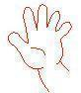 seeing

smelling



touching

Lesson three

Filling in missing letters

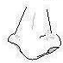

e__r n__se __ye le__



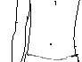

h__ir stom__ch han__

Lesson four

Write these words correctly.

era _______ seno _________ eey _______

ige _______ teos _________ ngerfi _________

Joining a puzzle

* face fingers leg hand ear

Caring for our body

Reciting a rhyme about the ways of caring for our body.

Teacher guides children and instructs them to mention the way how different body parts are cared for. e.g

teeth - by brushing

fingernails - by cutting them short

hair - by combing, cutting, plaiting, etc.

Activity

How can you care for your teeth?

I can care for my teeth by _______________

Draw these things we use to cut finger nails.

1. razorblades (ii) nail cutter

Match correctly



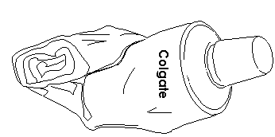 toothbrush

comb



razorblade



toothpaste

Talk about the importance of keeping our body clean e.g It makes us look smart, etc.

Talk about the dangers of cleaning the body. e.g It causes bad smell.

Lesson 6

I can locate the place where I live/stay

I live/stay at __________

My village is _____.

My home is found at __________________

Tings that make up a home.

kitchen

toilet

bedroom

bathroom

sitting room

Activity

Name the things found in the kitchen e.g saucepan, spoon, plates.

Where do we ease? (oral)

chairs, cupboard, table, carpet, television, (TV), radio, etc

Write the things we find in a bedroom. e.g bed, basin, wardrobe, mattress, blanket, pillow, suitcase, etc

Family members

recite a rhyme/sing a song about family members.

Mention family members (nuclear family) e.g father, mother, sister, brother, baby

Other family members extended family)

* aunt
* uncle
* cousin
* nephew
* grandfather
* grandmother

Activity

Who heads a family?

________heads a family.

Name these people found at home.

|  |  |  |
| --- | --- | --- |
|  |  |  |
|  |  |  |

Fill in the missing letters

f__ther m__ther si__ter br_ther

Colour these family members

Animals found at home.

* pig
* goat
* dog
* sheep
* cow
* rabbit

Activity

Write these words correctly.

pgi - _______

gdo - _______

oatg - _______

atc - _______

woc - _______

eepsh - _______

bbitra - ________

Read and draw

|  |  |  |  |  |  |
| --- | --- | --- | --- | --- | --- |
| pig | dog | cow | sheep | rabbit | cat |
|  |  |  |  |  |  |

Fill in missing letters.

sh__ __ p go__t c__w rab__it c__t

* Telling the role of each of the animal found at home.

Birds found at home. e.g duck , hen, turkey

Activity

Read and draw the birds.

What does the hen give us?

Fill in the missing letters.

h__n d__ck tu__key

Roles of family members

Tr. guides the children to discuss and discover the roles of different members e.g

Mother Father Children

* Cooks food - heads a family - Mop the house
* feeds the baby - Buys food etc - Sweep the compound
* Cleans the home - Wash dishes, etc
* Mops the house, etc

Activity

Pupils’ role play

* Draw Mummy cooking food

Name the things we use to clean the home.

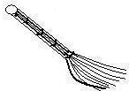



____________ __________

Lesson eight

Domestic animals which are not eaten.

dog

donkey

horse

camel

Use of animals (Things we get from domestic animals)

cow - milk, meat, dung, skin

goat - meat, milk, skin

dog - keeps/guards homes, it is a pet

sheep - milk, wool, manure

cat- eats rats, It is a pet

Activity

* Which animal guards the home? ____________________

Match correctly

cow wool

dog milk

sheep guards our homes

* Which animals eats rats from the house?_____________________

Animals used for transport

donkey

horse For carrying people and things. They are also used as pets.

camel

Lesson nine

Uses of birds. (Things we get from birds)

hen - eggs, chicken, manure

duck - eggs, meat

turkey- eggs, meat

Activity

Draw these things we get from a hen.

eggs chicken

Lesson ten

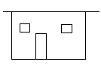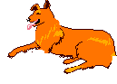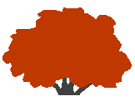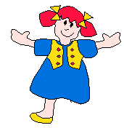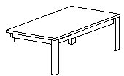Fill in the missing parts

Complete the pattern

123 123______ IIO= IIO= IIO=

Lesson eleven

Revision

Complete all the learnt activities.